How to upload files onto the WEAct website.
- From the website dashboard, select Media on the left menu.
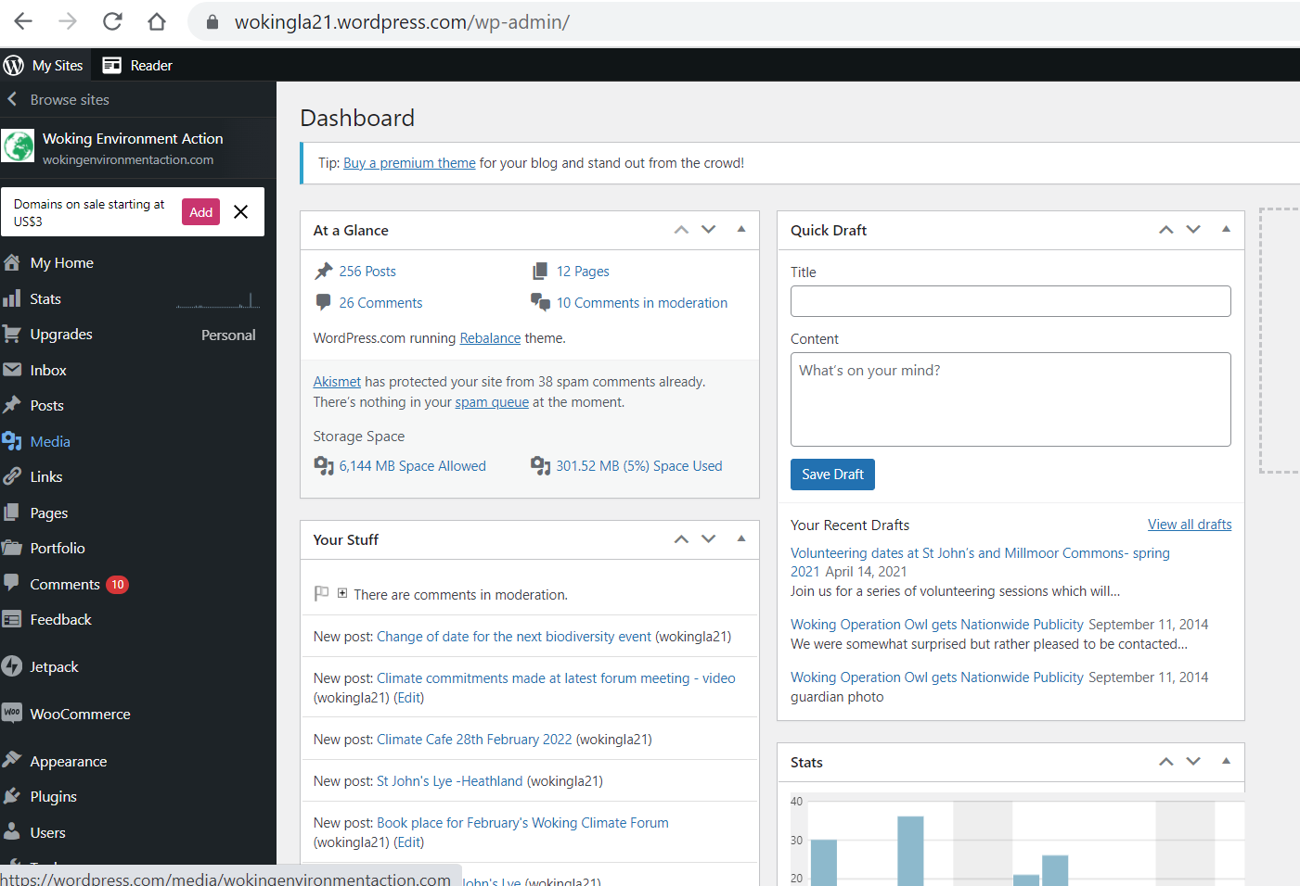
- Select Add New
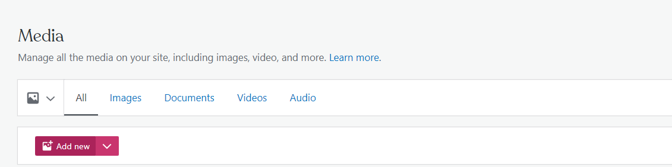
- Select a document / image from your own folder and click ‘Open’. This will upload the file successfully into the Media library and enable you to select in when trying to insert it into a post.

