WOKING BIODIVERSITY GROUP

VOLUNTEER WORK PARTY REPORT 2021

GENERAL
Despite not being able to start until April, this was our most productive year. Particular successes were the removal of balsam on two sites and the removal of invasive laurel at St Johns Lye. More wildflower locations were worked on and Millmoor Common is now completed subject to some maintenance during 2022. We were grateful for the Army (45 hours) and Affinity Water (125 hours) for providing volunteers for the balsam removal.

VOLUNTEERS
We are also grateful to our volunteers for all the work put in on our sites. A total of 756 hours (108 days equivalent) were worked. Volunteers provided by the Army and Affinity Water gave us support. During the September Big Green Week we were joined by a group from Linkable and some students from the Short Stay School. We now believe that support from local companies/groups is the way forward to achieving more targets during 2022.

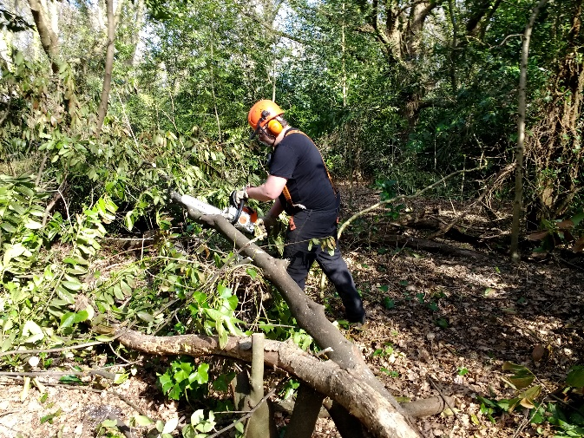
Qualified chain saw user Jonathan at work

SITES
During 2021 WBG carried out activities at:
- St Johns Lye
- Millmoor Common
- Mayford Meadows
- White Rose Lane
- Rydens Way and Westfield Estate and various sites for wild flowers
All these sites were supported by Woking Borough Council. Advice was also given to others at various sites in Woking.

HOURS/DAYS EQUIVALENT
A total of 756 hours (108 days equivalent) were completed on these sites. A more specific breakdown is shown below under each site heading.

Location | Hours Spent | Day Equivalent
St Johns Lye | 210 | 30
Millmoor Common | 190 | 27
Mayford Meadows | 83 | 12
White Rose Lane | 195 | 28
Wild Flower Sites | 78 | 11
Total | 756 | 108

ST JOHNS LYE
This Site of Nature Conservation Interest (SNCI) has recreational grassland, woodland, heathland, drainage dykes with running water and a pond area. Approximately 85% of the work undertaken was the removal of invasive species such as cherry laurel and the thinning of holly in accordance with our site woodland management plan. Logs/brash were used to create wood piles for insects/animals. A small amount of brash was burnt on site.
Our main objective for 2022 will be to continue the prevention of further spread of laurel from the east side to the west side of the site. Work was undertaken in the woodland area immediately to the east of the tarmac road running from the village up to the pedestrian railway bridge. Further tiding up of this area will be carried out during 2022.
The rest of our time was divided between protecting the remaining heather on the heathland (5%) and creating wildflower beds around the old football pitch (10%). No further work was carried out around the larger pond whilst awaiting work to be started by WBC on the drainage situation.

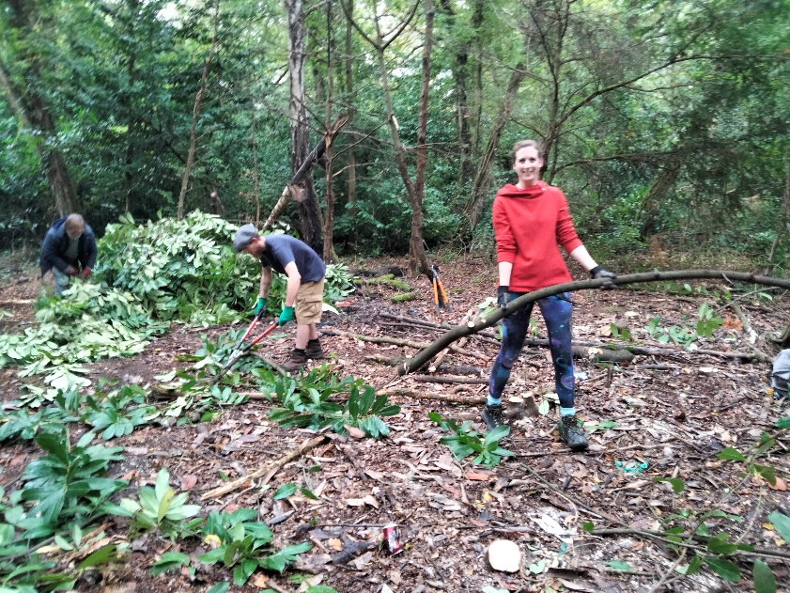
Volunteers at work on St Johns Lye

MILLMOOR COMMON
Another SNCI site with grassland, tree areas and a large pond. Significant progress has been made on the wildflower areas and more seeds were spread throughout the site. Work can now cease except for small maintenance during 2022. Numbers of wildlife continue to be spotted. A local bird review found over 40 different species. The wild flower area is increasing and over 40 species of wildflowers were recorded during the year. Time was spent on the wildflower area and in the woodland around the pond and other copse areas. Further nettles have been cleared in the designated areas and other overgrown areas along the main stream have been cleared.

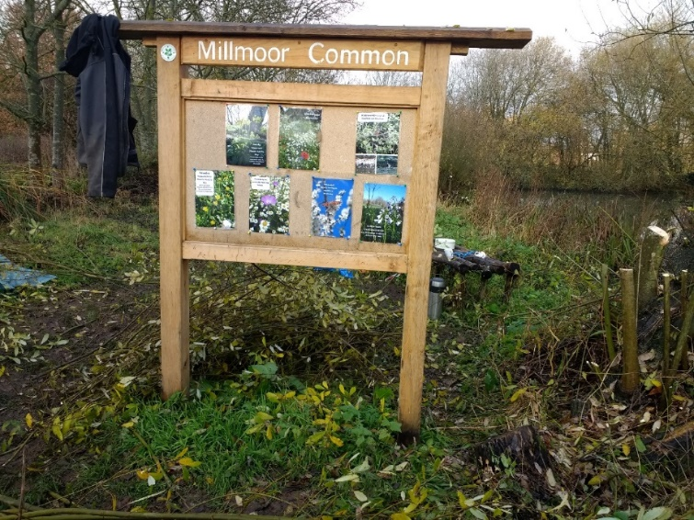
Signage installed at Millmoor Common

MAYFORD MEADOWS
Work was carried out in conjunction with the local residents to remove invasive Himalayan Balsam along the sides of the Hoe stream from the Guildford Road (Bird in hand end) up to the bridge opposite Willow Way. The area is now almost clear along the east bank and back into the woods on that side. Progress was made along the west bank but some areas will need more work during 2022. 83 hours (12 days) work was completed. 40 hours (7.5 days) of this by Affinity Water volunteers.

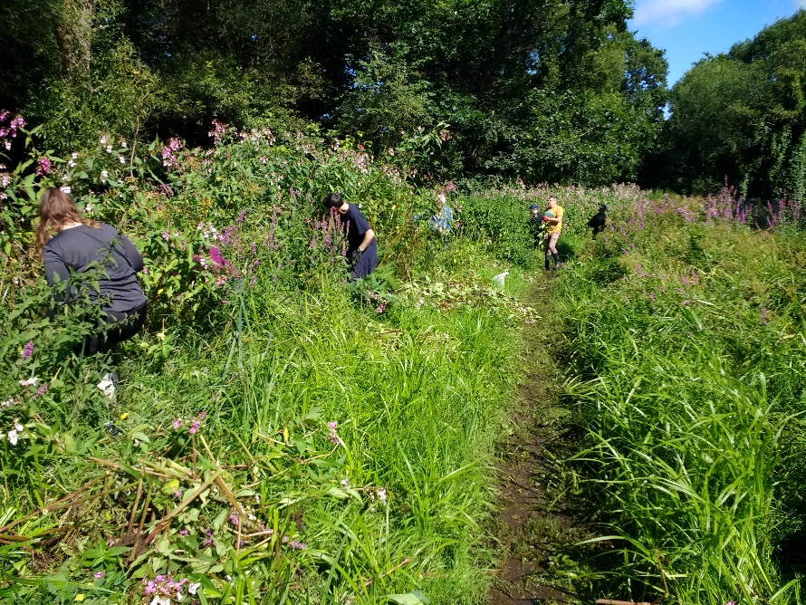
Affinity Water volunteers working at Mayford Meadows

WHITE ROSE LANE
The removal of invasive balsam at this site was our biggest success of the year. A total of 195 hours (28 days) were spent on site. This included 45 hours (6.4 days) by Army volunteers and 85 hours (12 days) by Affinity Water volunteers. We cleared the south bank of the Hoe Stream from the Leisure Centre up to the Hoebridge School. The north bank was cleared from the Utility building up to Hoebridge School. Both these areas will need to be revisited during 2022 to clear up surviving balsam. The White Rose Lane Reserve itself has vast amounts of balsam which we will tackle during 2022.

BIG GREEN WEEK
We arranged separate sessions during this week and were joined by new volunteers. A foraging for edible fruit walk was carried out at Millmoor Common. We also held a session with the Linkable Group removing bracken on St Johns Lye. A session was also held with three students from the NW Surrey Short Stay School.
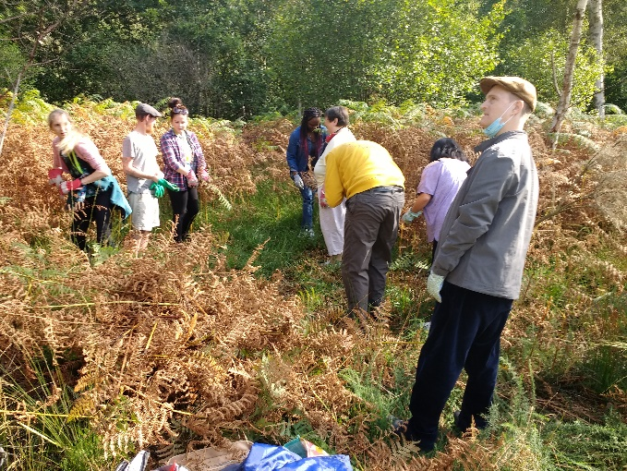
Volunteers from Linkable on site

WILD FLOWER AREAS
Maintaining wild flower sites and sowing new seed was carried out in Rydens Way and Westfield Estate. Also, work was carried out on several other smaller miscellaneous sites.
.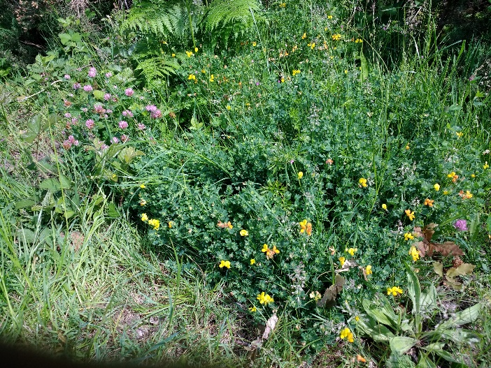
Wild flower area

SUMMARY
Whilst work at the start of 2021 was disrupted, we did manage a significant amount of work on some sites and the development of new sites for wildflowers during the rest of the year. Considerable progress was made at White Rose Lane and St Johns Lye. Help from Organisations/Companies was crucial to reaching our goals on the sites. We believe that help from outside companies and organisations is the way forward in the future. We would encourage anyone to contact us if they feel that this type of work would benefit team bonding and volunteering days for their companies/organisations.
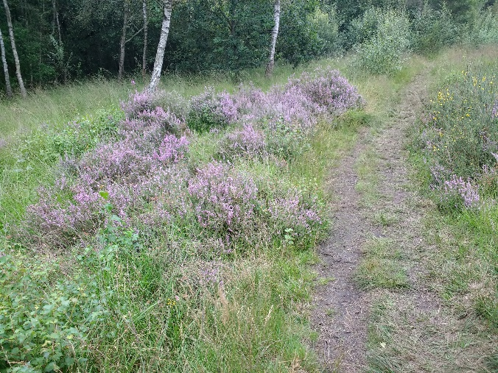
Protected heather on site

BLOG and WEBSITE
We continue to post blog notes on the Council Woking Environment Action site re progress and work dates. We plan to bring the website up to date

Ian Gammans
Woking Biodiversity Group
26 January 2022

